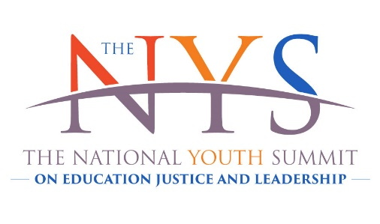
The National Youth Summit on Education Justice & Leadership SCHOLARSHIP SPONSOR FORM
For a fifth year, The National Youth Summit is bringing together high school students from cities across the U.S. They will work with over 20 national experts from corporations, government and universities to take ownership of their education and change the trajectory of their lives. With you help, they will help build safer, stronger, and better communities.
YOUR SUPPORT IS APPRECIATED. Donations will provide student scholarships to attend the three day summit.Please mail this completed form with payment or use our online option below. The Ethics Project is a 501(c)(3) non-profit organization, your donation is tax deductible.
Event Dates: October 28th and 29th Jackson State University & The Two Mississippi Museums
____________________________________________ Today’s Date _____________ Event Sponsor’s Name: (Business, Organization or Individual) __________________________________ _________________________________ Event Sponsor’s mailing address City /State/ Zip ________________________________________________ ___________________ Event Sponsor’s Contact’s Name & Title Phone: __________________________________ _________________________________ Email: Website:
Event Sponsor’s level of giving: (please check one)
______ Corporate Gold Leadership:…………………….……………......................................................$20,000
______ Corporate Silver Leadership:……………………………….........................................................$10,000
______ Justice Leadership........................................................................................................... $ 5,000
______ Community Partner ….………………………………………………………………....................................$ 2,500
______ Expo Event Table or Merit Scholar ……… ……..….………………………………………………………….$ 1,000
Payment method: (check one) ___ Check ___Credit Card ___Please invoice* (signature required)
Make checks payable to: The Ethics Project and mail to: The National Youth Summit, 40 N. Kingshighway, 12F, St. Louis, MO 63108 OR pay by debit or credit card here or online at TheNYS.org
Credit Card: ___MasterCard ___Visa ___Amex ___Discover
Card number: ____________________________________ Exp. Date: ________ CSV code on back_____
Authorized signature: ________________________________________________ Date: ______________
*Sponsor Signature: _________________________________________Date: ______________

Here’s what’s in it for you....
Scholarship sponsorship comes with the satisfaction of making it possible for youth in your community to participate in this extraordinary experience. In addition, the following sponsorship levels provide your company the following benefits:
………………………………...Corporate Gold Leadership sponsors ………………..…………………..
Extended solo, large screen display of logo on the Jackson State University McCoy auditorium • Logo on large vertical banner prominently displayed on site • Company ad on the inside cover or back cover of summit program booklet • Company name Included in press releases • Logo on posters distributed to hundreds of schools in the US • Logo Included in web page banner • Logo included in E-blast & social media • Event expo table during the summit upon request • 20 tickets to the opening reception.
………………………………………..Corporate Silver Leadership ………………….….………………………
Solo large screen display of logo at the Jackson State University McCoy Auditorium • Logo on life size vertical banner prominently displayed on site • Company ad prominently displayed in summit program booklet • Company name Included in press releases • Logo on posters distributed to hundreds of schools in the US • Logo included in web site banner • Logo included in E-blast & social media • Event expo table during summit upon request. 10 tickets to the opening reception.
……………………………………………..… Justice Leadership …………………..……………….………………
Large screen display of logo at Jackson State University McCoy Theater • Logo displayed on life size vertical banner prominently displayed on site • Company name/logo displayed in the program booklet • Company name Included in press releases • Logo on posters distributed to hundreds of schools in the US • Logo Included in web site banner • Logo included in E-blast & social media • Event expo table during summit upon request. Invitation for six to the opening reception.
…………………………………………………..Community Partner………………………………………………..
Large screen recognition with logo included in group image on screen at Jackson State University McCoy Auditorium and on life size banner • Logo/name Included in web page banner • Event expo table upon or invitation for two to the opening reception. Table is non-transferrable.
…………………………………………………………Merit Scholar…..………….......................................
Big Screen Recognition (Name included in group on screen during the Summit) • Name listed on web page • Two tickets to the opening reception.
…………………………………………………………………….Expo Table………………………………………………………
Expo tables will be on the Mezzanine of the Two Mississippi Museums on day two of the summit.

