The National Youth Summit on Education, Justice, and the US Economy
PASSING THE TORCH
On November 12, 2017, The National Youth Summit on Education, Justice, and the US Economy will open with a historic ceremony that includes a Passing of the Torch to nine outstanding youth from across the country. Each recipient will have exhibited the leadership, service, and commitment needed to move our country forward in a positive direction. The torch will be passed to them by civil rights leaders from the Civil Rights Movement of the 1960s – And you can be a part.
PASSING THE TORCH SPONSORSHIP FORM
The name of torch sponsors or co-sponsors will appear on the engraved placard on the rear of the torch and will appear in the program. Gold sponsors will also receive six VIP tickets to the opening ceremony and reception. Early donations help us plan this exceptional opportunity for attendees. Please return this completed form along with your donation payable to The Ethics Project to: The National Youth Summit, c/o The Ethics Project, 40 N. Kingshighway, 12F St. Louis, MO 63108. The Ethics Project is an award winning 501(c)(3) non-profit organization. Donations are fully tax deductible.
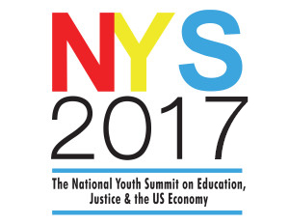
_________________________________________ ___________ ________ Sponsor’s Name: (Business, Organization or Individual) Today’s Date _____________________________________ ______________________ Sponsor’s mailing address City /State/ Zip _____________________________________ ______________________ Email Address: Phone #:
______ Torch Co-Sponsor……………………….………………......................................................$250
______ Torch Sponsor………..………………………………………………………………………………………………...$500
______ Gold Torch Sponsors …………………………………………………………………………………….………………$1000
Payment method: (check one) ___ Check ___Credit Card ___Please invoice* (signature required)
Checks can be made payable to: The Ethics Project and mailed to: The National Youth Summit c/o The Ethics Project, 40 N. Kingshighway 12F, St. Louis MO 63108
Credit Card: MC Visa Amex Discover
Card number: ____________________________________ Exp. Date: ________ CSV code on back_____
Authorized signature: ________________________________________________ Date: ______________
*Sponsor Signature: _________________________________________Date: ______________

